Power BI Assignment 1 – Data Transformation & Data Modeling
Import Data
Step 1: Import “List of Orders.csv” into Power BI.

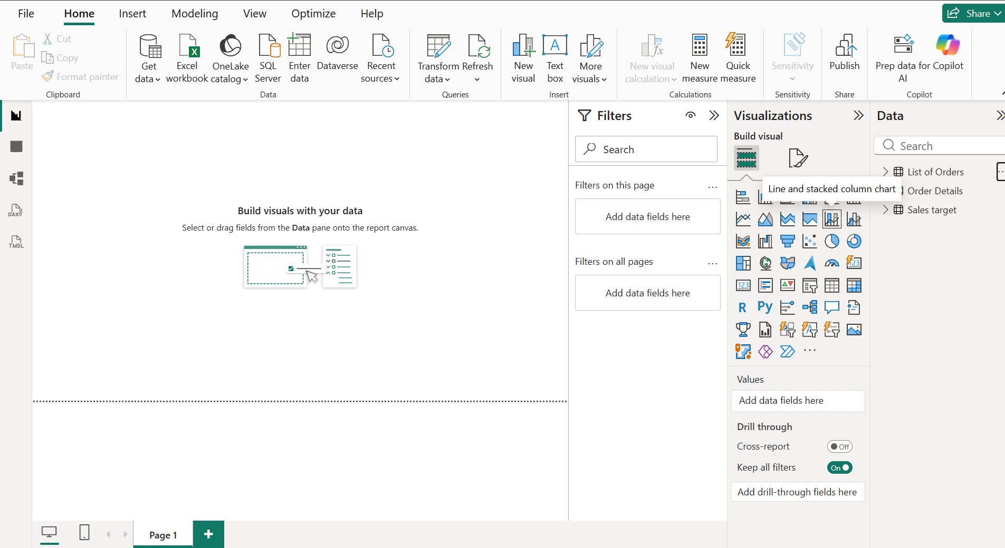

Step2 : Import “Order Details.csv” and “Sales target.csv” into Power Query Editor.
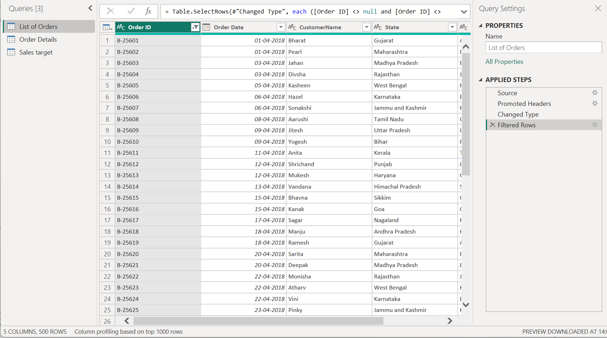

Data Transformation
Step1: Restrict the "List of Orders" table to only the first 500 rows.
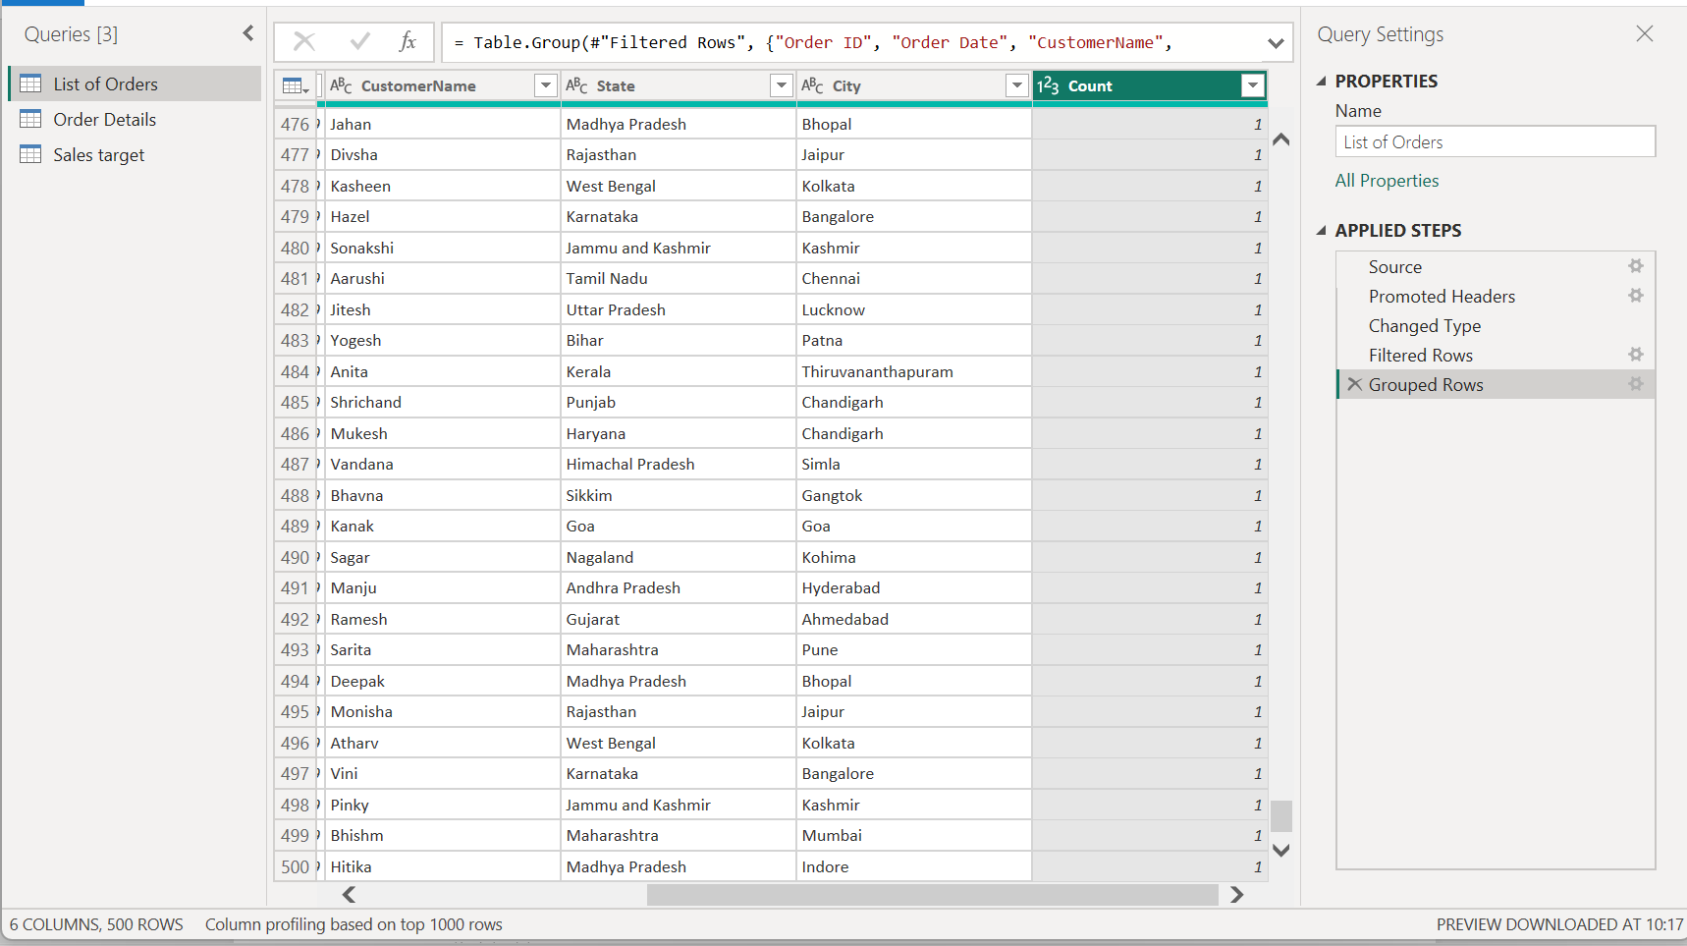
Step2: “Order Date” column in the “List of Orders” table is set to data type 'Date'.
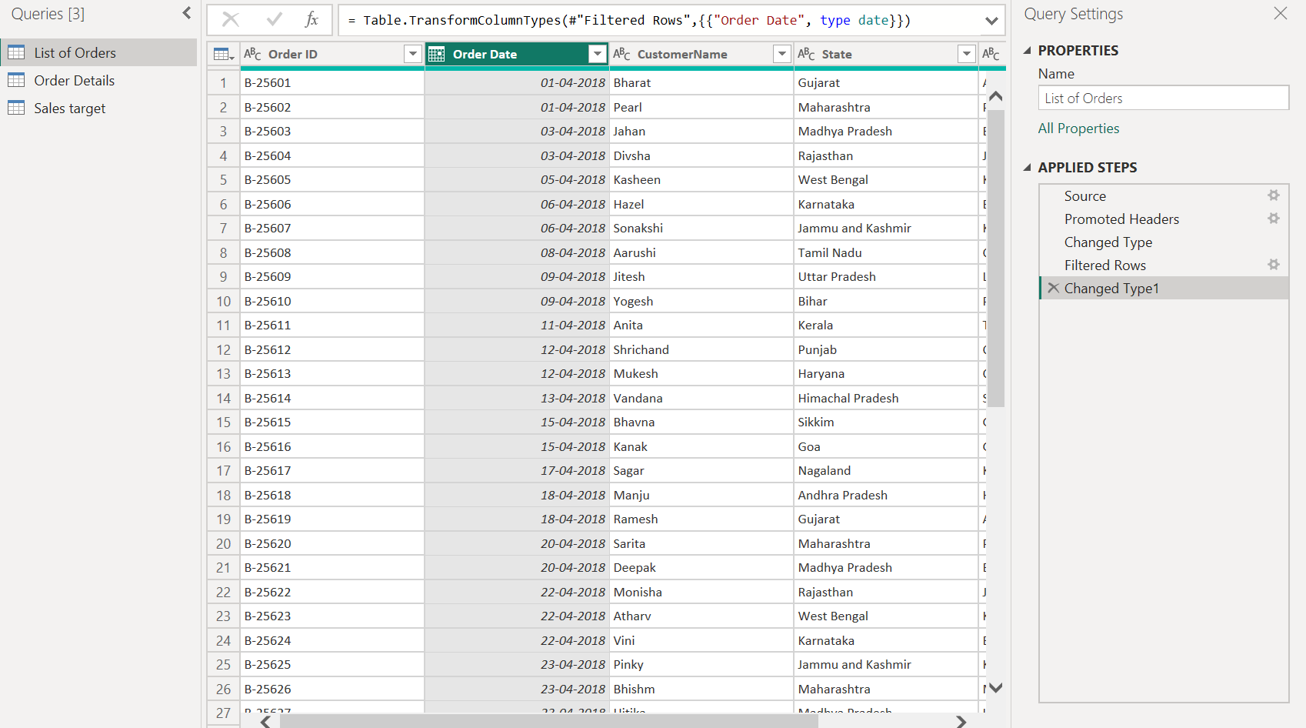
Step3: Change the data type of “Amount” and “Target” columns to ‘Fixed Decimal Number’.
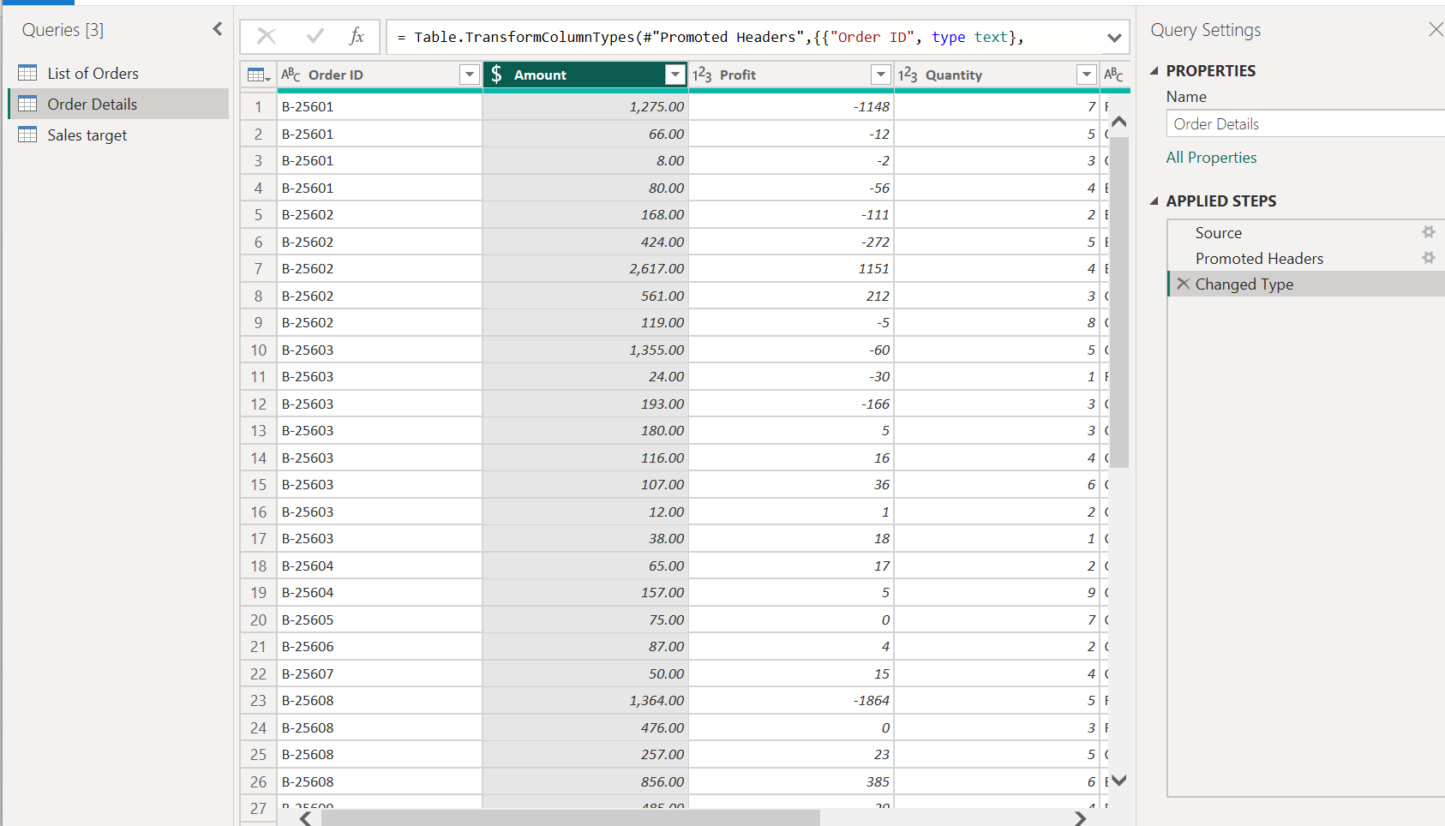

Step4: Format the "CustomerName" column into proper case, ensuring consistent capitalization for each word.
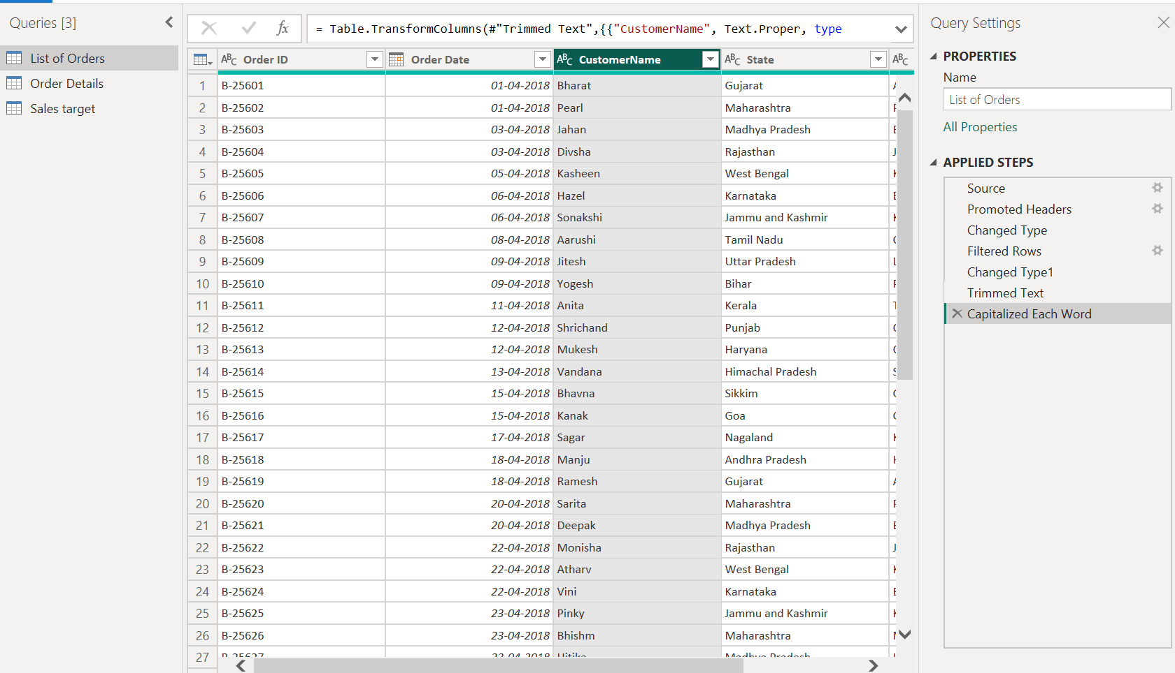
Step5: Merge the "State" and "City" columns to create a new column named "Location" in the format ‘City, State’.
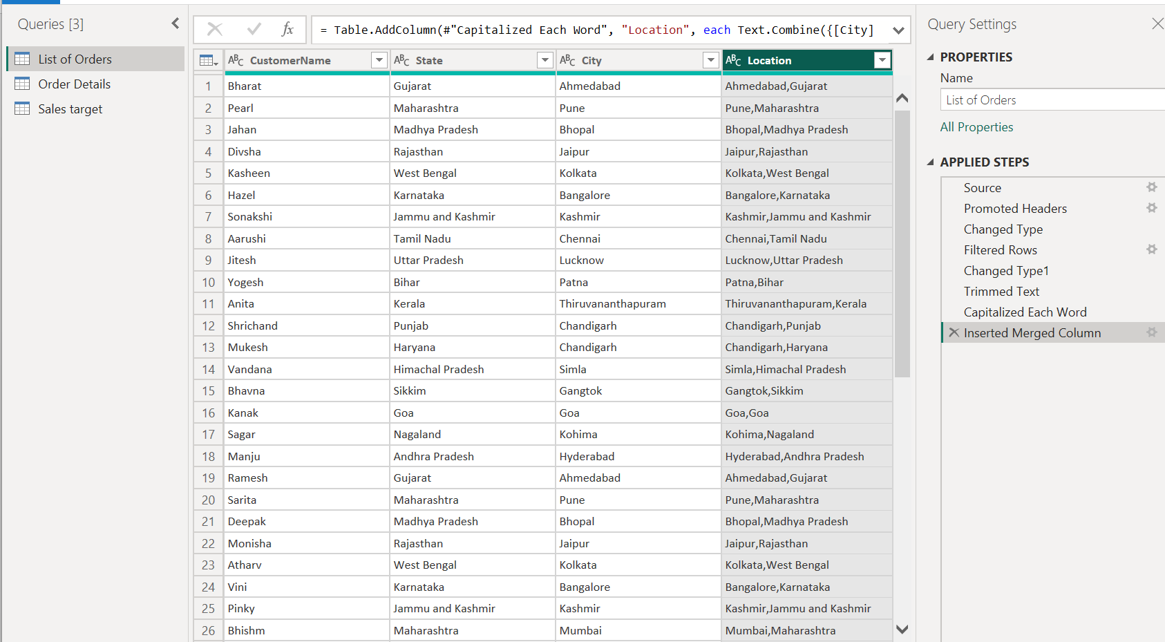
Step6: Create a new custom column named "Profit Margin" as the percentage of "Profit" divided by "Amount".
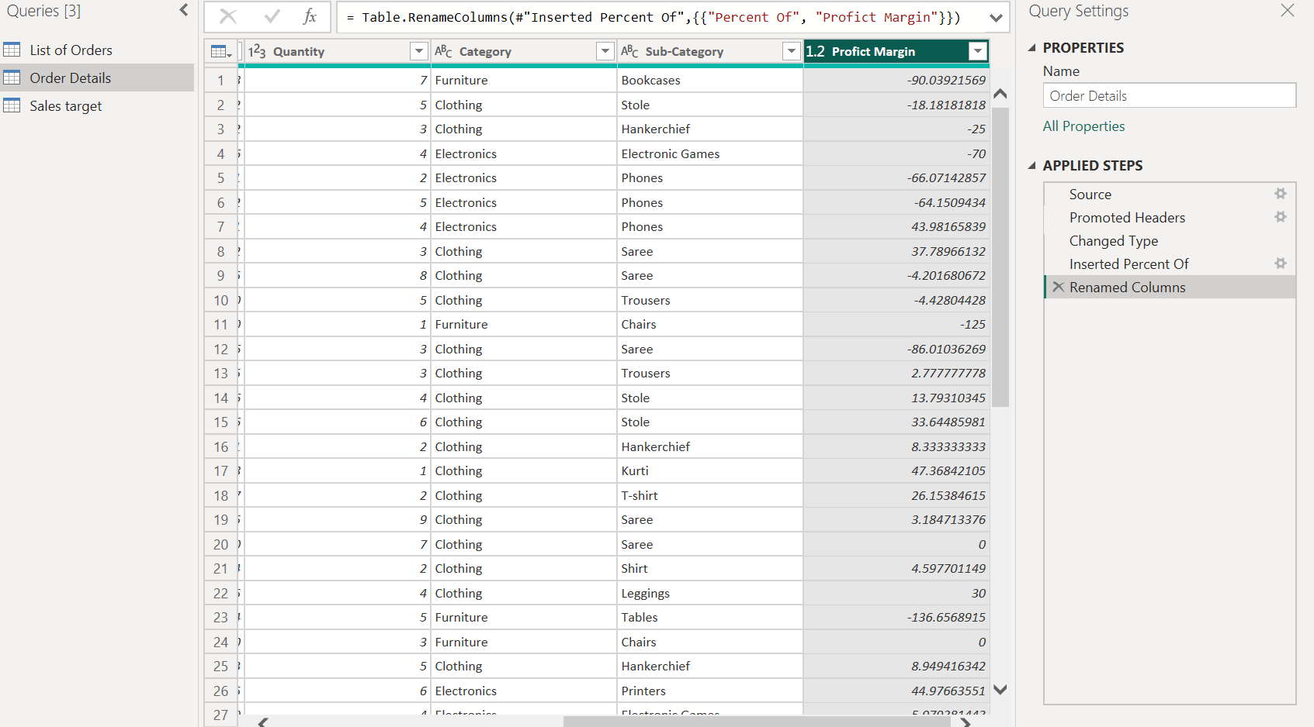

Step7: Add a new conditional column named "Profit Status" based on the values in the "Profit" column. The conditions are as follows: if the profit is less than 0, the label should be "Loss"; if the profit equals 0, the label should be "Break-Even"; and if the profit is greater than 0, the label should be "Profit".\
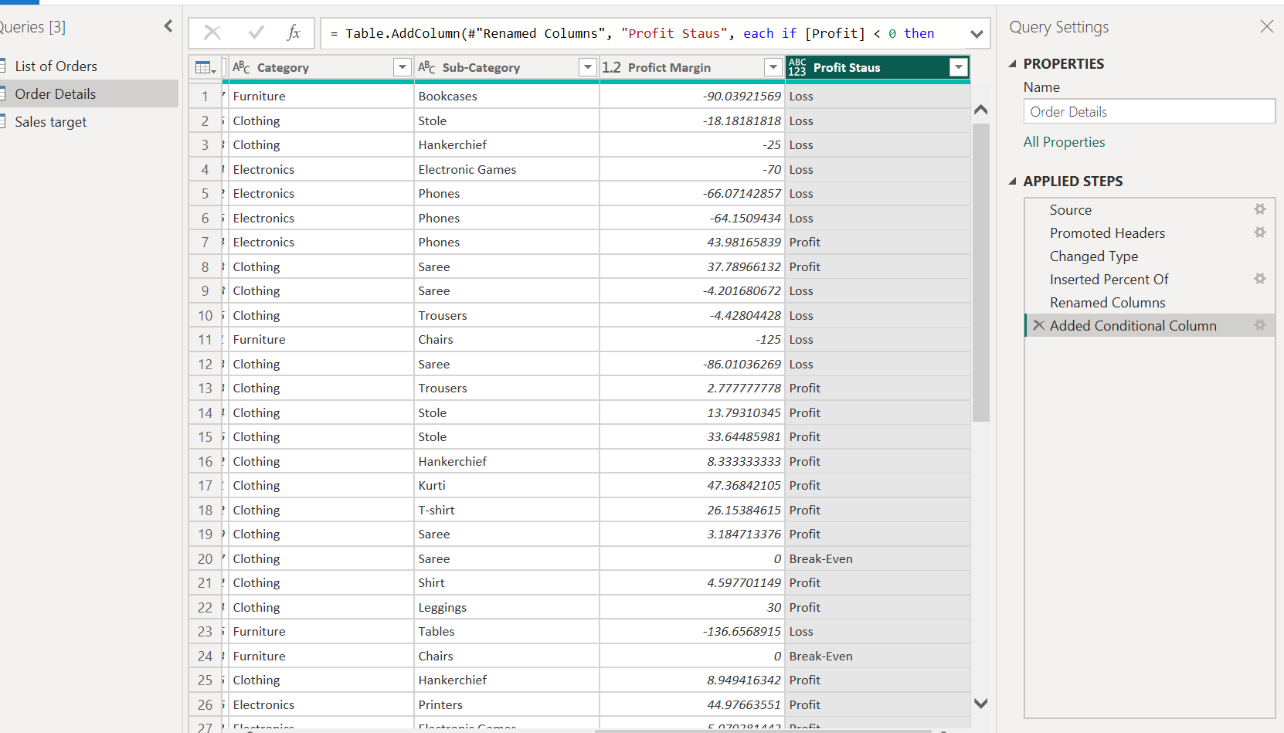

Merging Data (Joins)
Merge the "List of Orders" and "Order Details" tables into a new single table named "Orders Data" based on the "Order ID" relationship.
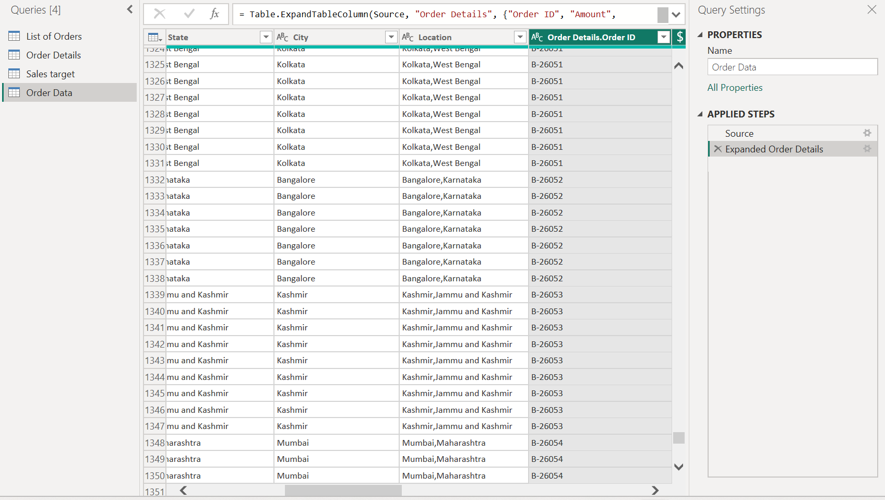

Handling Missing Data & Duplicate Data
Step1: Identify missing values in the data and determine a strategy to address them.
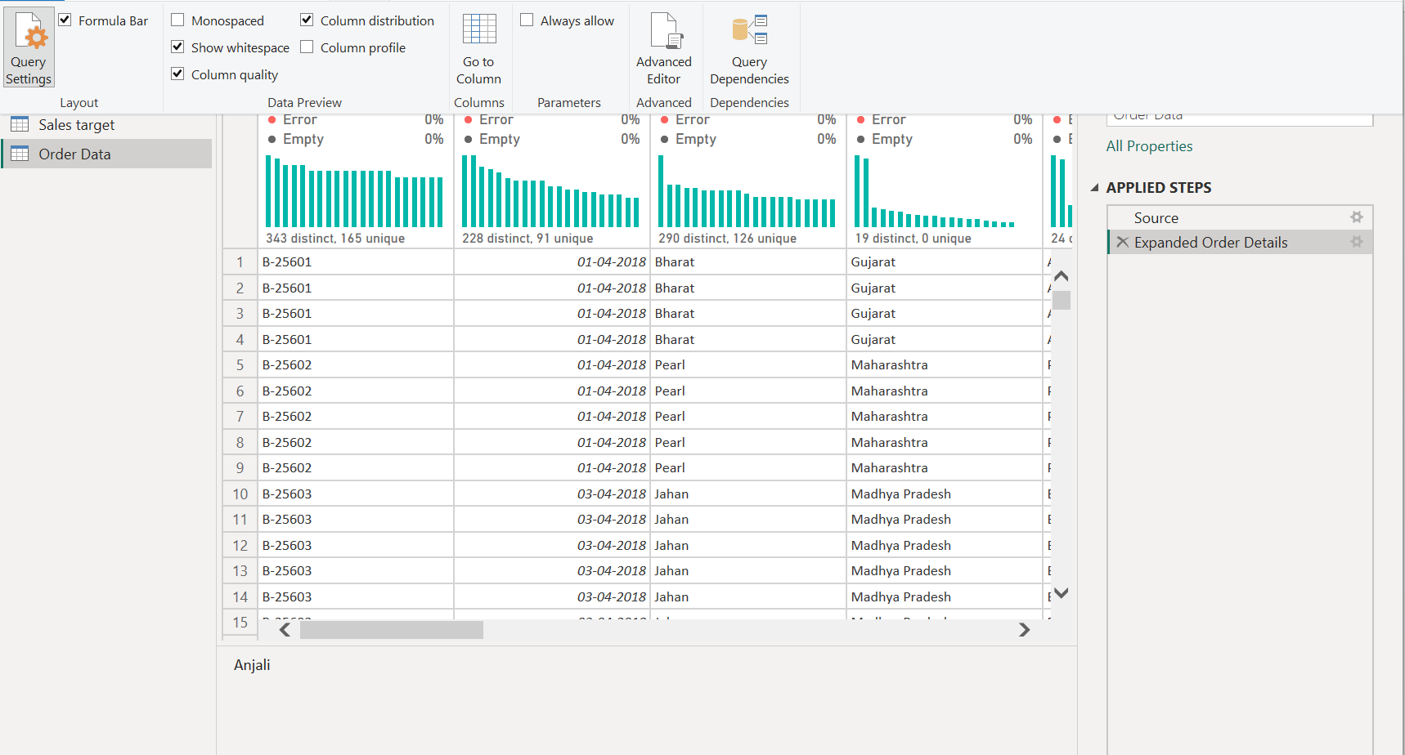
Step2: Check for duplicate rows and define a strategy to handle duplicates.
Removed duplicates using the “Remove Duplicates” step.
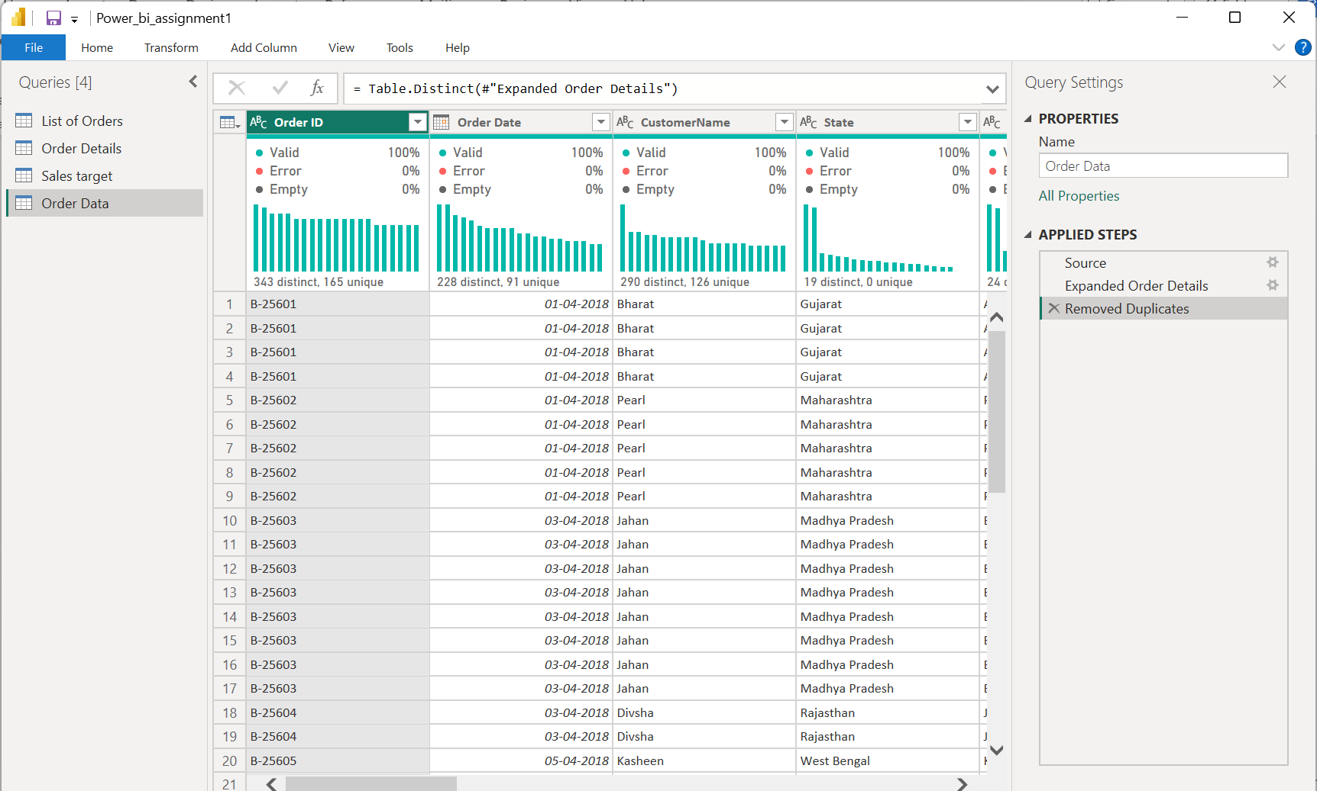
Sorting and Filtering Data:
In the ‘Orders Data’ table, utilize sorting and filtering techniques on columns like Order Date, State or Category to analyze data based on specific criteria:
Step1: Sort the orders by Order Date in descending order to analyze recent trends.
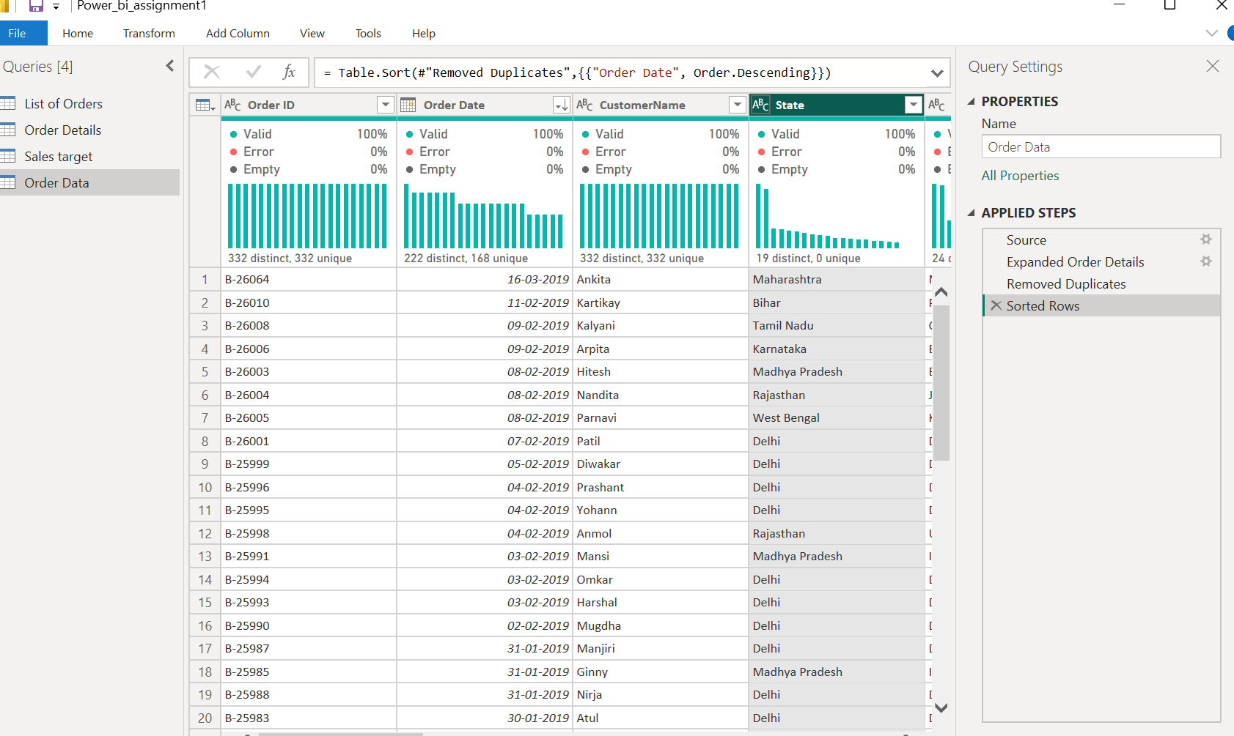

Step2: Filter the orders to focus only on a specific state (e.g., Tamil Nadu) for regional analysis.
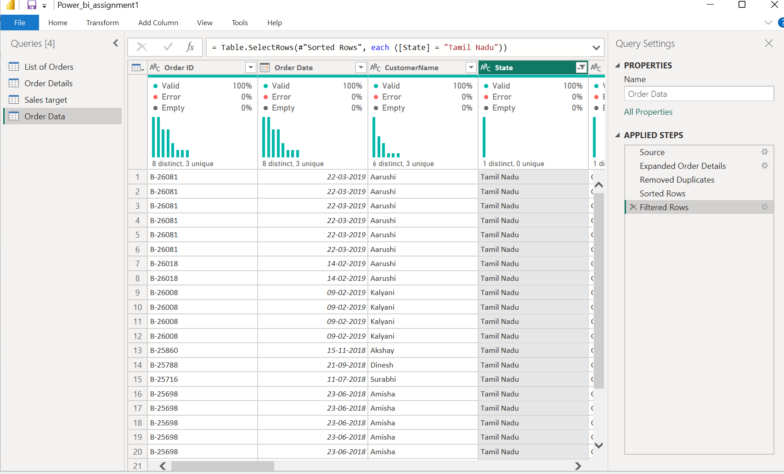

Grouping and Aggregating Data:
Step1: Duplicate the “Order Details” table and calculate the count of each Order Id
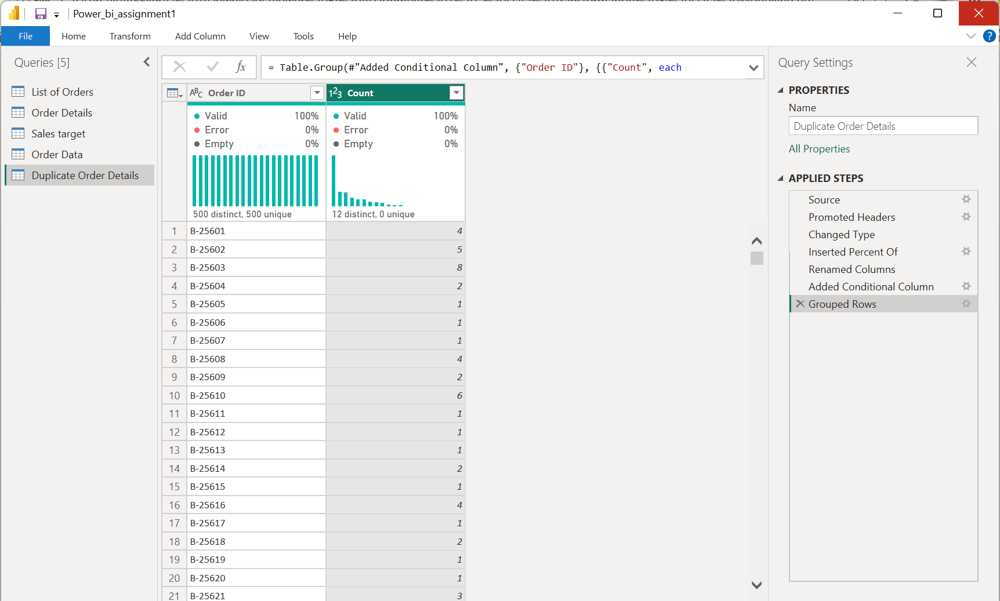

Step2: Average profit by Category
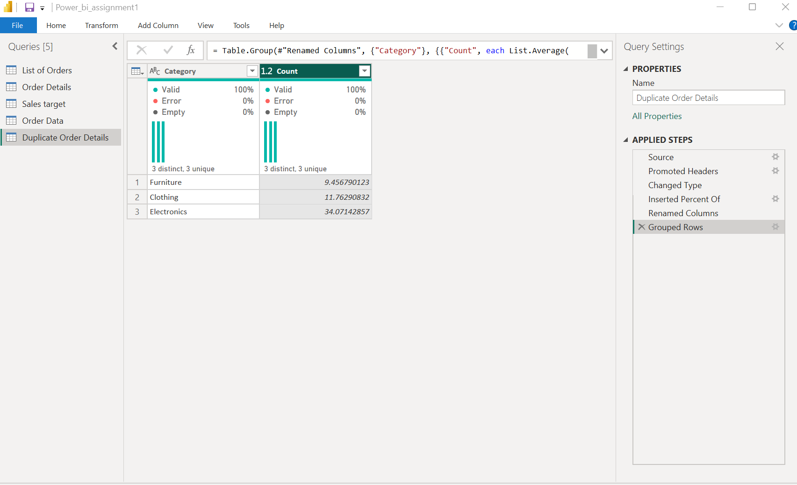
Step3: Total amount by Sub-Category
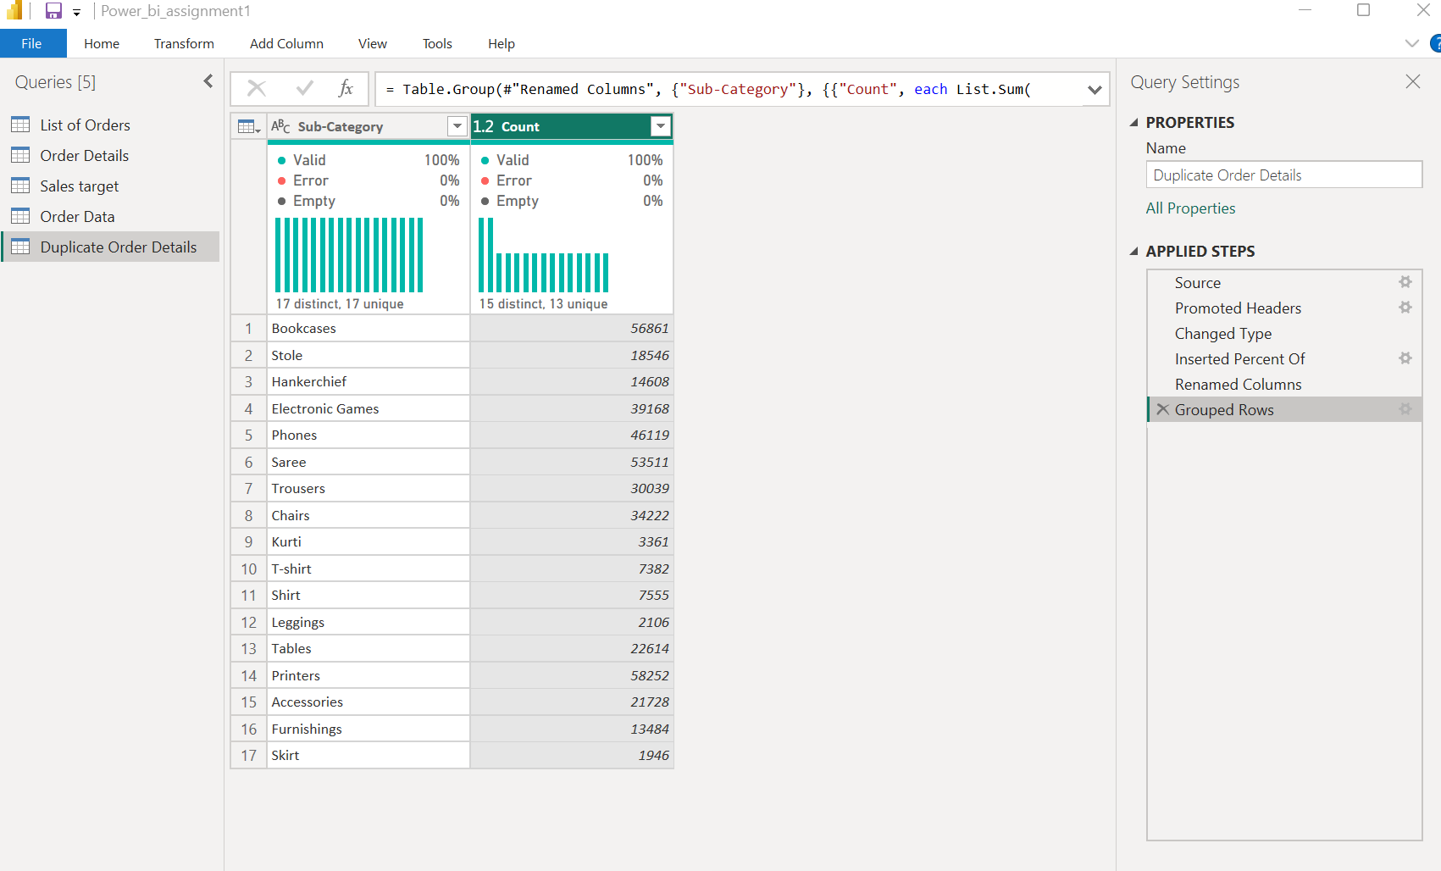

Data Modeling:
Step1: Establish a relationship between the “List of Orders” and “Order Details” tables using the ‘Order ID’ column.
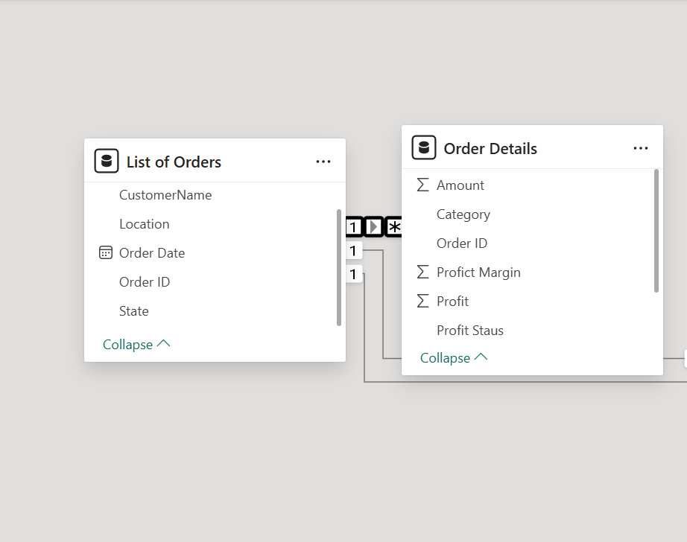

Step2: Build a relationship between the “Order Details” and “Sales Target” tables based on the ‘Category’ column.
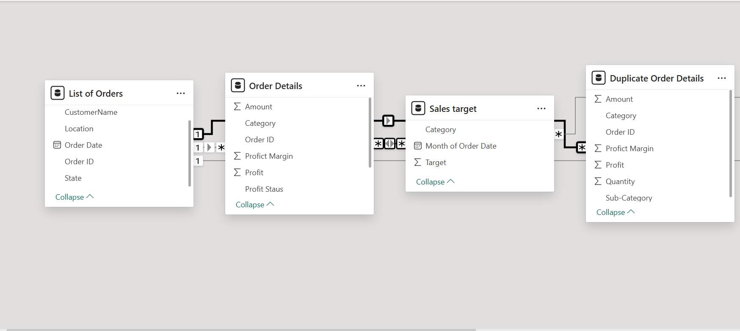

Step3: Click "Manage relationships" and ensure this relationship is active.

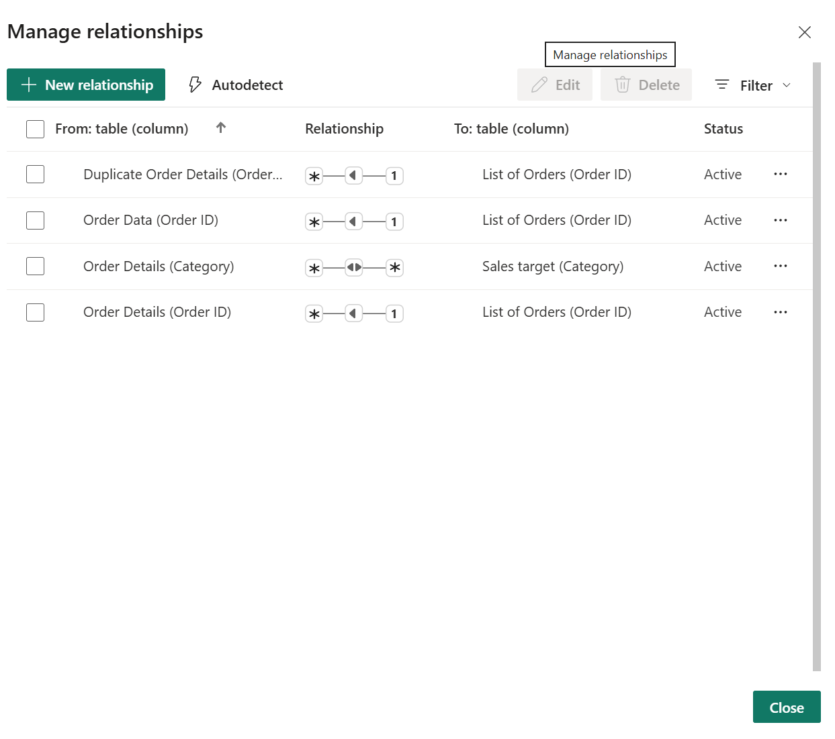

Conclusion
This Power BI report demonstrates a complete data analytics workflow, including data import, transformation, merging, cleaning, sorting, filtering, aggregation, and modeling. Key relationships were established between tables using Order ID and Category, with active links verified in the model view. All steps were executed according to assignment requirements, and the final model is ready for analysis and visualization.

